**Software Design Specification:**

**Theater Ticketing**

By: Luis Suarez, Hailun Xu

System Description

The system to be constructed will have the main function of being a ticketing service for a local San Diego cinema chain. It will also host a secondary function of being a customer feedback system, a user profile service, and an AMC subscription service.

Software Architecture Overview

The architecture diagram of all major components is the following:

UML Class Diagram

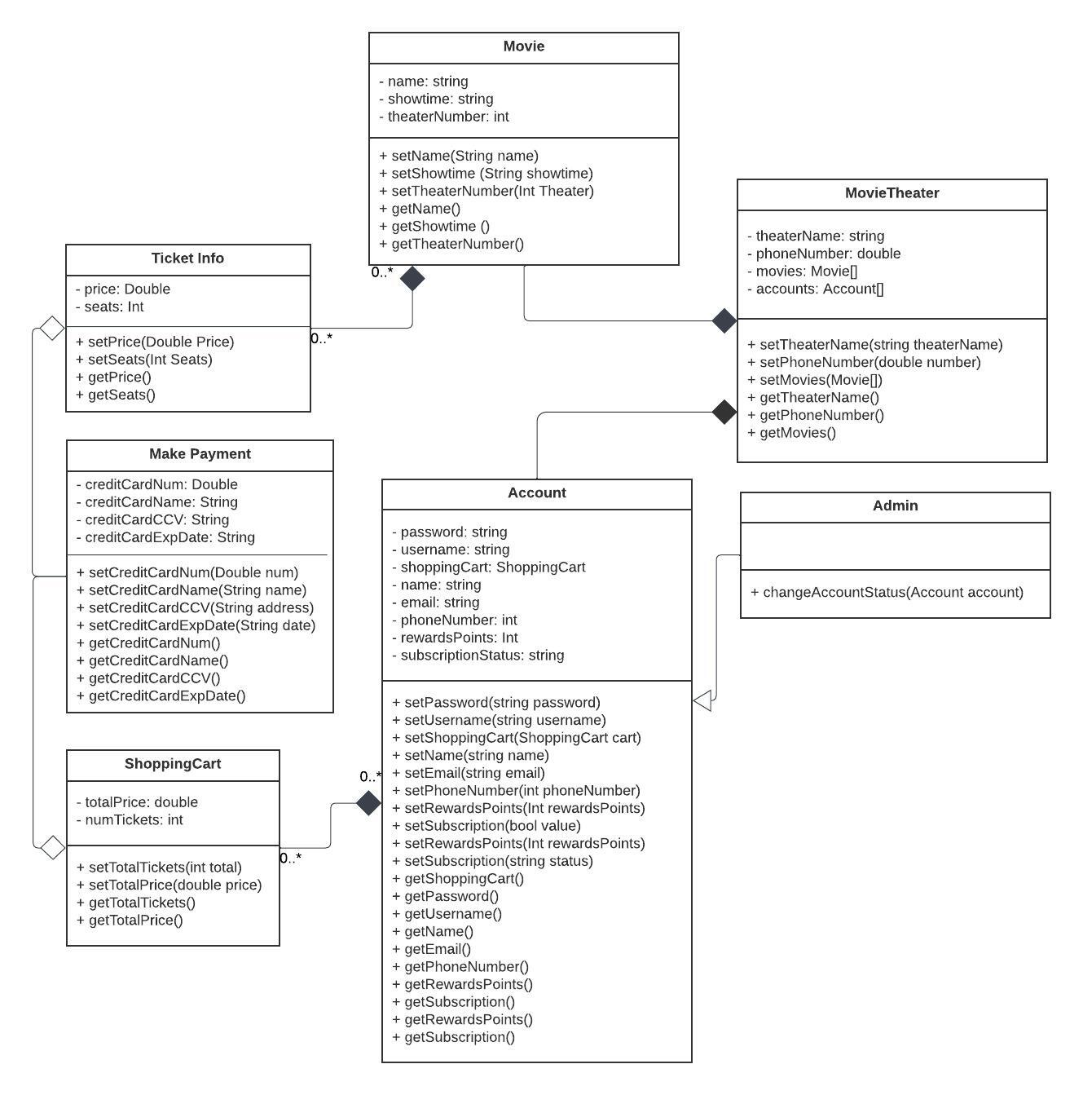

Classes, Operations and Attributes

Movies [class]: This class defines the attributes of the films that will be screening in this cinema chain. They will have all the attributes that any film should have: a name, showtime, and screen number.

setName(string name): This operation will set the name by passing in a String as an argument.

setTime(string time): This operation will set the showtime by passing in a String as an argument.

setLocation(string location): This operation will set the cinema location by passing in a String as an argument.

setTheaterNumber(int number): This operation will set the screen number by passing in an integer as an argument.

Ticket Info [class]: This class defines the attributes of the tickets for a particular film at a cinema. They will hold a particular price as well as how many tickets are left for sale.

setPrice(Double price): This operation will set the price of a ticket for a particular film by passing a double as an argument

setSeats(int seats): This operation will set the number of seats left for sale for a particular film by passing an int as an argument.  
---------------------------------------------------------------------------------------------------

Make Payment [class]: This class defines the attributes of the films that will be screening in this cinema chain. They will have all the attributes that any payment should have: credit card number, name of the credit card holder, address of the credit card holder.

setCreditCardNum(double num): This operation will set the credit card number of the holder when making a payment by passing in a double as an argument

setCreditCardName(string name): This operation will set the name of the credit card holder when making a payment by passing in a string as an argument

setCreditCardCCV(int num): This operation will set the credit card CCV number (the 3 digits on the back of a credit card) when making a payment by passing in an integer as an argument

setCreditCardExpDate(String date): This operation will set the credit card expiration date when making a payment by passing in a string as an argument

---------------------------------------------------------------------------------------------------

Account Info [class]: This class defines the attributes any general account for the cinema chain will have. They will have the attributes that any generic account, regardless of the user, should have including: a password, username, name, email, phone number, and an online shopping cart for the website.

setPassword(string password): This operation will set the password to a particular account made by passing in a string as an argument

setUsername(string username); This operation will set the username to a particular account made by passing in a string as an argument

updateShoppingCart(ShoppingCart cart): This operation will update the shopping cart of a particular user by passing in an object of the class type ShoppingCart (explained later) as an argument

getShoppingCart(): This operation will retrieve the online shopping cart of a particular account

---------------------------------------------------------------------------------------------------

User Info [class]: This class defines the attributes that an account should have in reference to a particular user. They will have attributes such as: name, email, and a phone number for the website.

setRewardsPoints(int rewardsPoints): This operation will set the num of rewards points a particular user has accumulated thus far by passing in an integer as an argument

setSubscription(bool value): This operation will set whether a particular user has the AMC subscription for the cinema chain by passing in a boolean as an argument

setName(string name): This operation will set the name of a particular user by passing in a string as an argument

setEmail(string email): This operation will set the email of a particular user by passing in a string as an argument

setPhoneNumber(double phoneNumber): This operation will set the phone number of a particular user by passing in a double as an argument

getName(): This operation will retrieve the name of a particular user

getEmail(): This operation will retrieve the email of a particular user

getPhoneNumber(): This operation will retrieve the phone number of a particular user

---------------------------------------------------------------------------------------------------

Shopping Cart [class]: This class defines the attributes that the online shopping cart would have of a particular user for a cinema chain. They will include attributes such as: the total price of the tickets, and the number of tickets purchased.

setTotalTickets(int total): This operation sets the current total number of tickets that the shopping cart for a particular user holds by passing in an integer as an argument

setTotalPrice(double price): This operation sets the current total price of the tickets that the shopping cart for a particular user holds by passing in a double as an argument

---------------------------------------------------------------------------------------------------

Movie Theater [class]: This class defines the attributes that a particular cinema in the cinema chain should have. They will include attributes such as: the name of the particular theater, the phone number to the particular theater, and the movies screening at the particular theater.

setTheaterName(string name): This operation sets the name of a particular theater in the cinema chain by passing in a string as an argument

setPhoneNumber(double number): This operation sets the phone number of a particular theater in the cinema chain by passing in a double as an argument

setMovies(Movies[]): This operation sets the list of films being screened at a particular theater by passing in an array of objects of the class type Movies (explained previously) as an argument